PHASE IV: PROJECT DESIGN
Date | 05 November 2025
Team ID | NM2025TMID03595
Project Name | Garage Management Application
Maximum Marks | 4 Marks

Title: Project Design Phase for “Garage Management Application – A Salesforce-Based Workshop Automation System”

1. Objective
The objective of the Design Phase is to define the technical, logical, and user interface architecture of the Garage Management Application.
This phase translates user and business requirements into a structured design, ensuring that the system automates garage operations such as appointment scheduling, service tracking, billing, and customer management using Salesforce tools.
This design focuses on:
- Interface Design (UI/UX)
- Automation Design (Flows and Triggers)
- Security Model Implementation
- Dashboard and Reporting Layouts

2. Design Overview
The design uses Salesforce’s declarative (point-and-click) and programmatic (Apex) features to create a robust, efficient system for managing automotive service centers.
The Garage Management app includes:
- Five Core Custom Objects: Customer Details, Appointment, Service Records, Billing Details & Feedback, and Vehicle Details
- Automated Flows for appointment and service tracking
- Apex Triggers for automatic status updates
- Dashboards for real-time performance insights
- Profiles and Sharing Rules for secure, role-based data access

3. User Interface (UI) Design

3.1 Lightning App Design
A custom Lightning App named “Garage Management” was designed to streamline all service operations from a single interface.
Steps to Create:
- Go to Setup → App Manager → New Lightning App
- Add App Name, Description, and icon
- Configure navigation tabs as follows:
- Home
- Customer Details
- Appointments
- Service Records
- Billing & Feedback
- Reports
- Dashboards
Design Principles:
- User-Centric Layout: Quick access to key objects
- Clean, Minimal UI: Simplified screens for faster workflow
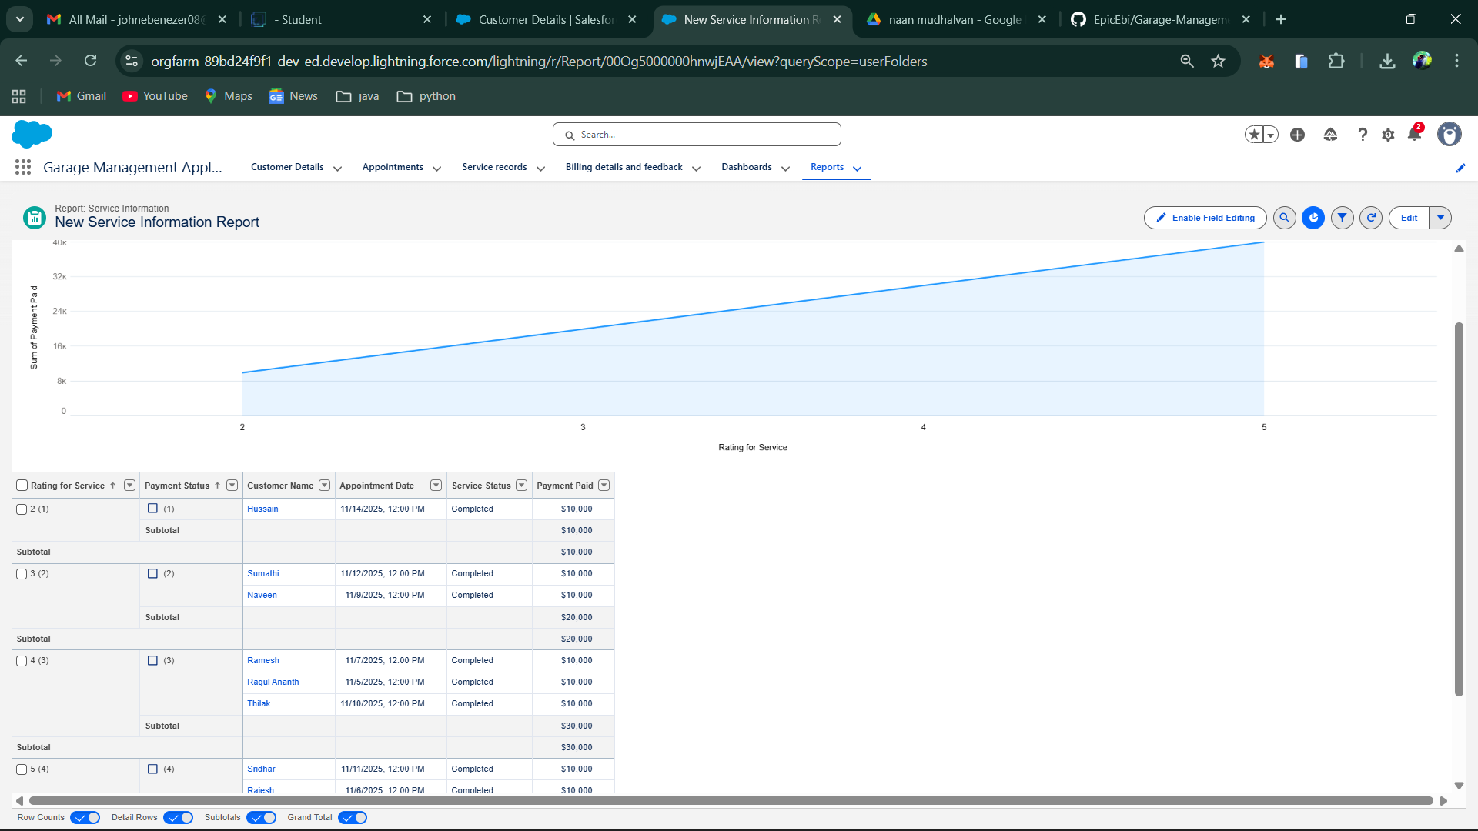

3.2 Home Page Design
The Home Page acts as a control center for service operations.
Components Added:
- Screen Flow: “Appointment Booking Flow” for customer scheduling
- Embedded Dashboard: Displays total services, completed tasks, and daily revenue
- Info Banner: Shows real-time garage announcements or updates

4. Automation Design
Automation ensures a hands-free workflow by minimizing manual interventions and maintaining data accuracy.

4.1 Screen Flow: Venue Form Flow
This flow simplifies appointment creation and links it with customer records.

Flow Steps:
- Screen inputs: Customer Name, Vehicle Number, Appointment Date, Service Type
- Create Record: Save appointment under the selected customer
- Auto-calculate service cost
- Confirmation message: “Appointment successfully created!”
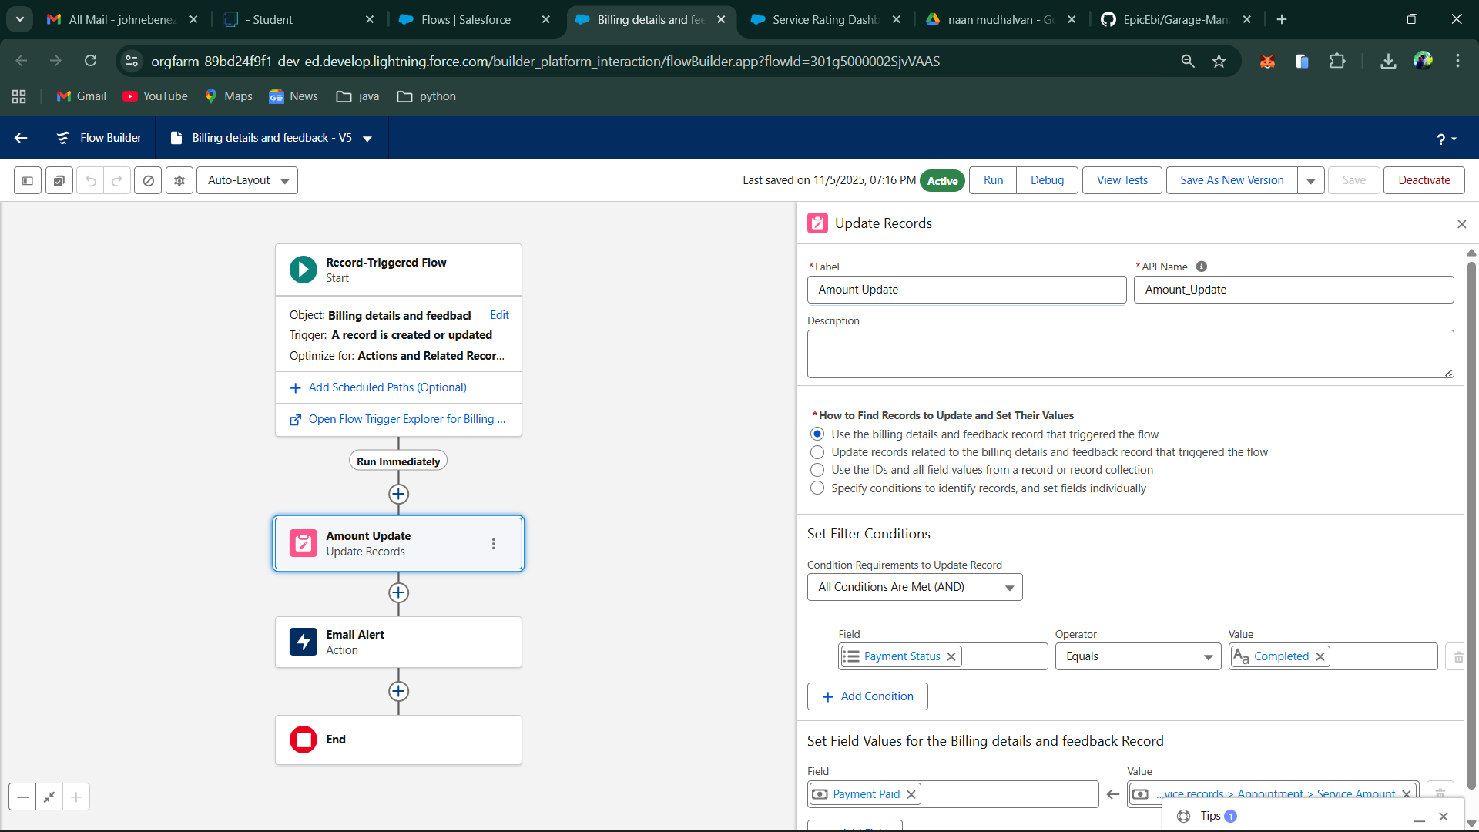

4.2 Apex Trigger Design
A custom trigger on the Service Record object automatically updates the Service_Status__c field when the Quality_Check_Status__c is set to True.
Trigger Logic:
- Event: Before Update
- If Quality_Check_Status__c = True → Set Service_Status__c = "Completed"
- Save the record
Rationale:
Ensures seamless workflow automation, reducing manual updates and maintaining data consistency.

5. Security Design
The Security Model in Salesforce ensures data privacy and controlled access among users.

5.1 Profile-Based Access
- Manager Profile: Full CRUD access on all objects
- Technician Profile: Limited access to assigned services and billing updates
- Receptionist Profile: Access to customer and appointment modules only

5.2 Sharing Rules Configuration
- If Service_Status = Completed → Share with Manager
- If Payment_Status = Pending → Share with Receptionist
Benefit:
Enforces role-based data visibility and prevents unauthorized modifications.

6. Reporting and Dashboard Design

6.1 Reports
Custom Report Types were built to link:
- Customer → Appointment → Service Record
- Service Record → Billing & Feedback

6.2 Dashboard Components
A live dashboard provides instant visibility into garage performance
Components Used:
- Bar Chart: Total Appointments vs Completed Services
- Pie Chart: Payment Status Breakdown (Paid / Pending)
- Line Chart: Monthly Service Growth
- Table View: Customer Ratings and Feedback Summary
.
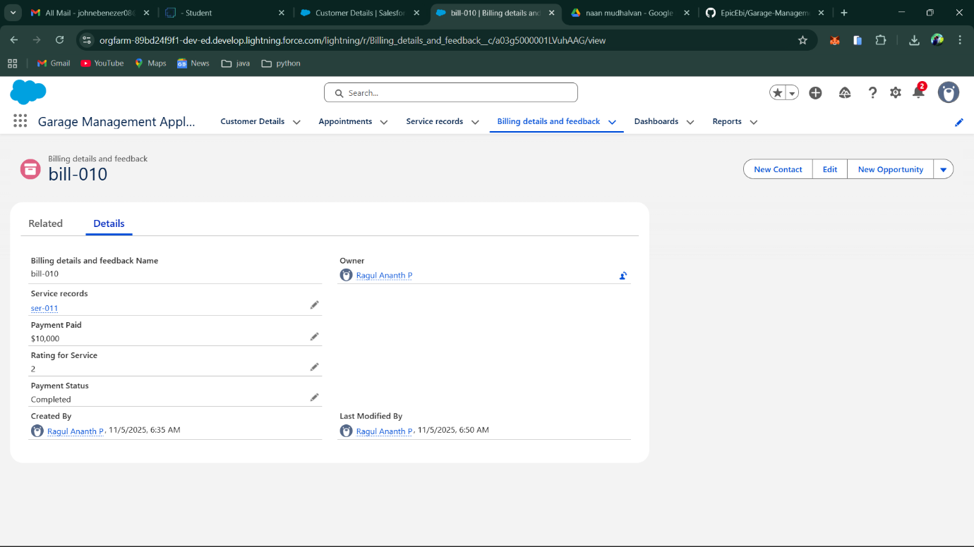

7. System Architecture Design
The system architecture integrates UI, automation, database, and reporting modules into one functional ecosystem.
Layer | Component | Function
Presentation Layer | Lightning App UI | User-facing interface for all operations
Logic Layer | Apex Triggers, Flows | Automates core business processes
Data Layer | Custom Objects, Fields | Stores all garage-related records
Analytics Layer | Dashboards, Reports | Provides visual performance metrics

8. Design Constraints
Constraint | Impact | Solution
Large data volume in service records | Slightly slower dashboard load | Apply data filters for time periods
Formula recalculation delay | Slower response during bulk updates | Use batch processing
Concurrent data edits by users | Record locking conflicts | Enable field-level security and sharing rules

9. Future Design Considerations
- Integration with WhatsApp API for instant service notifications.
- SMS alerts for service completion and billing updates.
- Development of a Salesforce Mobile App for technicians to update work status on-site.
- Predictive maintenance suggestions using AI based on vehicle history.

10. Summary
The Project Design Phase successfully transformed the functional requirements into a scalable, automated Salesforce solution for garage operations.
Key Achievements:
- Simplified and interactive Lightning UI
- 100% automated workflow through Flows and Triggers
- Role-based security and record sharing
- Real-time reporting and service monitoring
This design ensures efficiency, transparency, and scalability for automotive service centers using Salesforce as a unified digital platform.

